More notes on observations and likelihoods

- New observation type @abundance.

Example

@abundance CPUE
q CPUEq
year 1
timestep 1
categories immature mature spawning
selectivities ONE ONE ONE
year 1998
layer SSRU
obs A 25
obsB 30
obs C 1
obs D24
cv A 0.2
cv B 0.3
cv C 0.2
cv D 0.2
dist lognormal
cv_process_error 0.40

Notes: Here we have one observation of abundance for each grouping of a layer (e.g., layer SSRU =A)

First, calculate expected numbers.

Here, its just the sum of the total vulnerable individuals in each cell, i.e. multiply the number at age l in category k by the selectivity at l, then sum over ages and sum over categories

Calculate dRes = sum over categories (sum over ages( V(k,l) = N(k,l) * S(l) ) )

Then sum over cells in the layer with grouping A, B, etc.

We then multiply dRes in each group by the q value, CPUEq in this case.

But, now we need to supply the q value (labelled CPUEq in the example)
We need a new command

@q CPUEq
type free
q=0.0001

Which, at this stage has a subcommand that defines a q value with the label CPUEq, and a type that defines its type (there’s only the free method now, but later we could add one more, type=nuisance (Nuisance is a bit trickier, but it’ll work within this conceptual framework).

And (if we wish to estimate it - actually it would be silly not to), we can use

@estimate
parameter q[CPUEq].q
lower_bound 1e-10
upper_bound 1.0
prior Uniform

From that, we get a single number of abundance in the cells for each grouping value of the layer. Call these the Expected numbers.

The lognormal likelihood is then calculated as,

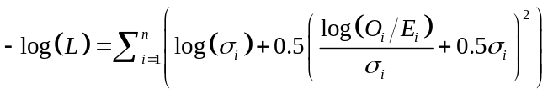

where 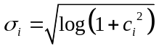.

With c_{i} = 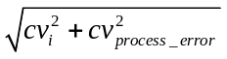

Pseudo code:

First calculate c for each ‘layer group’ as supplied

c = sqrt(pow(cv,2) + pow(process_errror_cv,2))

and then calculate sigma_{i} = sqrt(log(1+pow(c_{i},2)))

set dRes = 0

The iterate over the groupings of the layer,

tmp = log(Oi/Zerofun(Ei,delta))/sigma_{i} + 0.5*sigma_{i}
dRes = dRes + log(sigma_{i}) + 0.5 * pow(tmp,2)

And the resulting likelihood is just dRet.

